
A12
Sreenidhi Institute of Science & Technology
(An Autonomous Institution)
Code No: 3CC08
B. TECH. III – Year I – Semester Examinations, December 2014 (Regular)
SIGNALS AND SYSTEMS (EEE)

Time: 3 Hours Max. Marks: 70

Note: No additional answer sheets will be provided.

Part - A
Max.Marks:20

Answer all QUESTIONS.

1. Derive the relationship between Energy and Power signals.
2. Define Gibb’s Phenomenon.
3. Write short notes on Poly-Wiener criterian.
4. Find the final value of the function F(s) given by (S-1) / S(S²-1)
5. State sampling theorem.
6. Determine Z transform of the following sequence.
x[n] = [1, 2, 3, 4, 5, 0, 2]

7. Give the mathematical and graphical representation of continuous time and discrete
time signals with example.
8. Test whether the following system is causal or non causal
y(t)=x(2t)+x(-t)
9. Define Autocorrelation function and explain its significance.
10. Write Short notes on Bilateral and Unilateral Z-Transforms.

Part – B
Max.Marks:50

ANSWER ANY FIVE QUESTIONS. EACH QUESTION CARRIES 10 MARKS.

- a) What is the Analogy between Vectors and Signals.
b) Determine whether the signal x(t)=sin 20πt + sin 5πt is periodic or not. If it is periodic, find the fundamental period.

- a) Write notes on Dirichlet conditions.
b) Find the Fourier series of the following wave form.

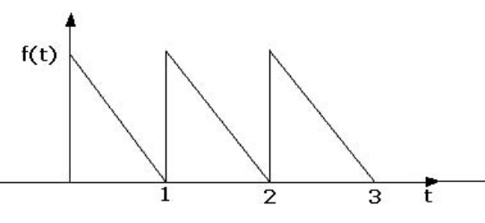

- a) Test the following systems for Linearity, Causality and Time-invariance.
i) y(t) = e ^{x(t)} ii)y(t) = log₁₀ ^{x(t)}
b) Write short notes on distortion less transmission through a system.

4. a) Find and sketch the convolution of the two signals.
x(t) = e^{-at} u(t) and h(t) = u(t).
b) Show that auto-correlation function and energy density spectrum form a
Fourier transform pair.

- a) Define and draw aliasing phenomenon in frequency domain.
b) A signal x(t) is given as x(t)=6 cos 10 πt. This signal is sampled by an impulse train. The sampling frequency of the impulse train are 7 Hz and 14 Hz. Draw the spectra of the original signal. Also draw the spectra of the sampled signal with sampling frequency 7 Hz and 14 Hz.

- a) Determine inverse Z- transform of the following by using power series method.
X(z) = 1 / (1-az⁻¹) |z| > |a|
b) Use convolution sum to determine discrete-time signal s[n] if S(z) is given by
1
S(z) = ------------------------------
(1- ½ z⁻¹) (1+ ¼ z⁻¹)

- a) Derive the relationship between exponential and trigonometric Fourier series
coefficients.
b) Find the Fourier transform of the signal given by
y(t) = cos(10t), −2< t< 2
0, otherwise

8. a) Write and explain properties of ROC of Laplace transform of signals.
b) Determine and sketch the auto correlation function of exponential pulse.
x(t) = e^{-at} u(t).

-- 00 -- 00 –

